Student-Attendance-Tracking-System

Download link for Android Studio –> <https://developer.android.com/studio>

Here are the Steps for installation of “Android Studio” and to open the Project.

1. Open the link 🔗 above provided and click on download.

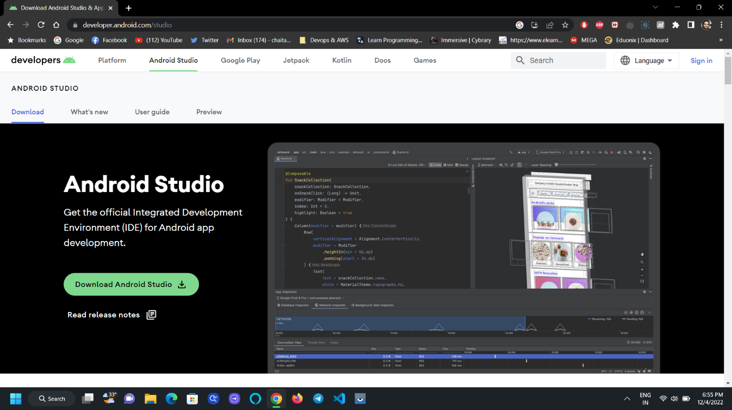

1. Scroll down to accept the terms and Conditions & click on Download Android Studio for Windows and Continue.

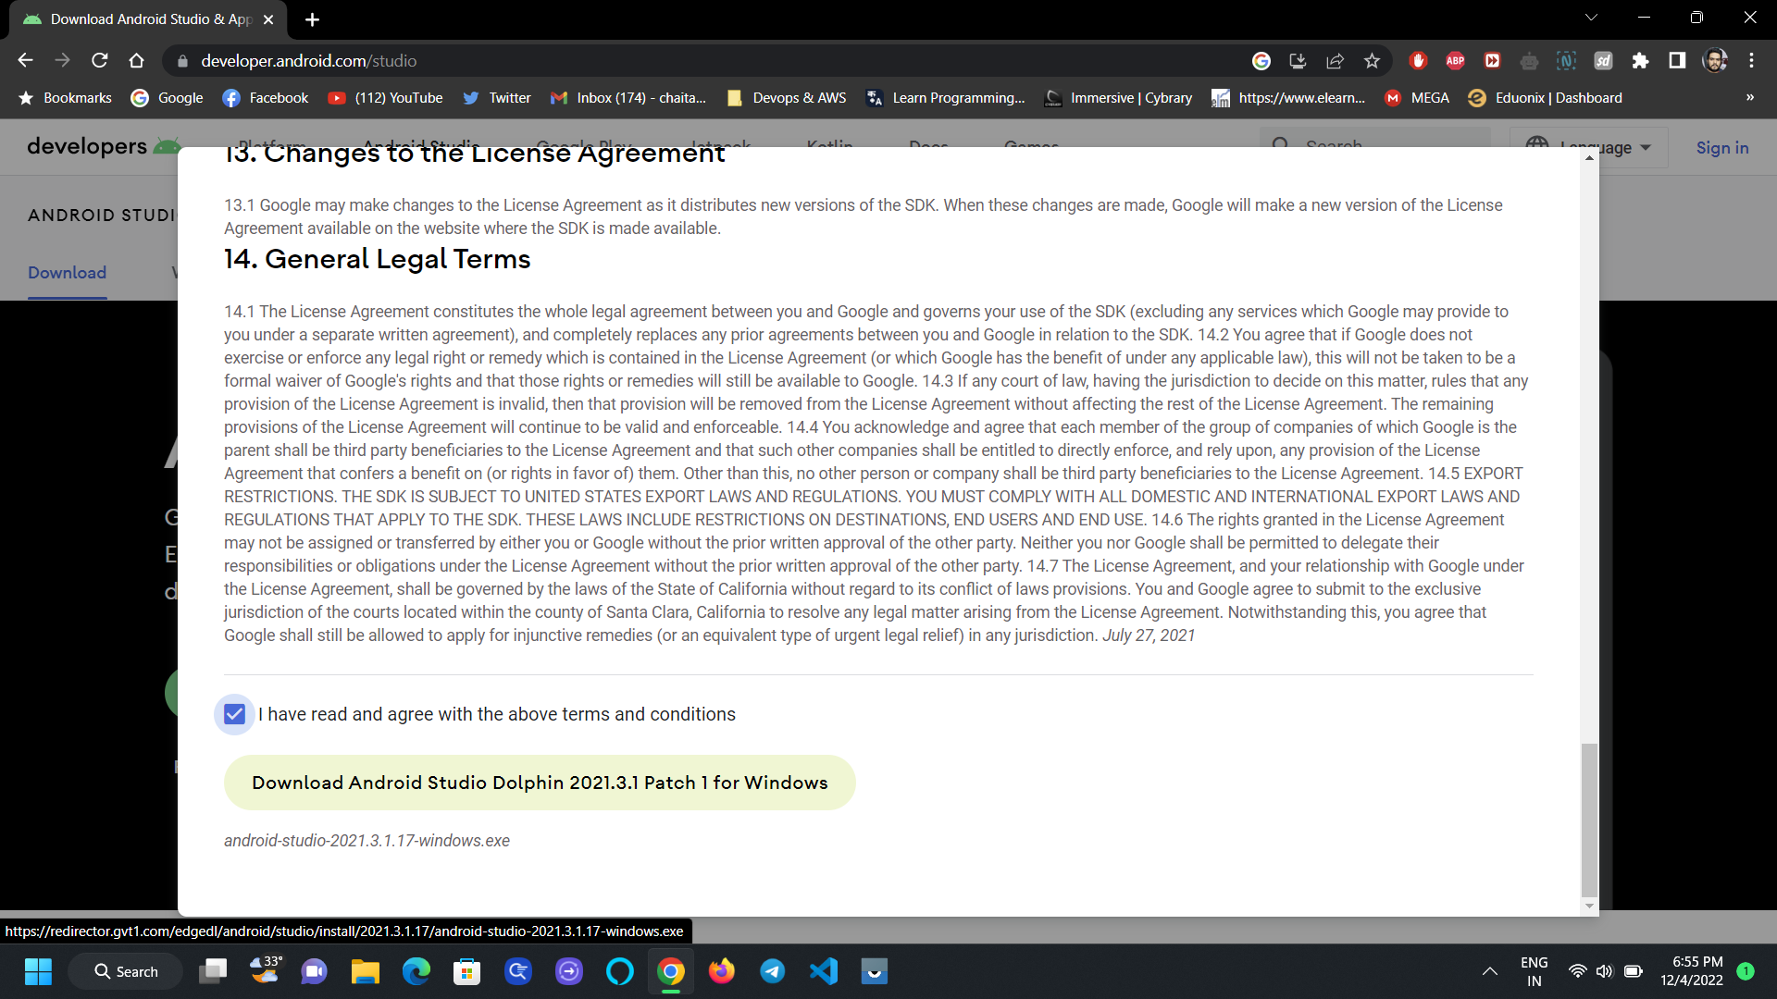

1. After Clicking on the download a popup will appear to choose the destination path, choose any location you like.

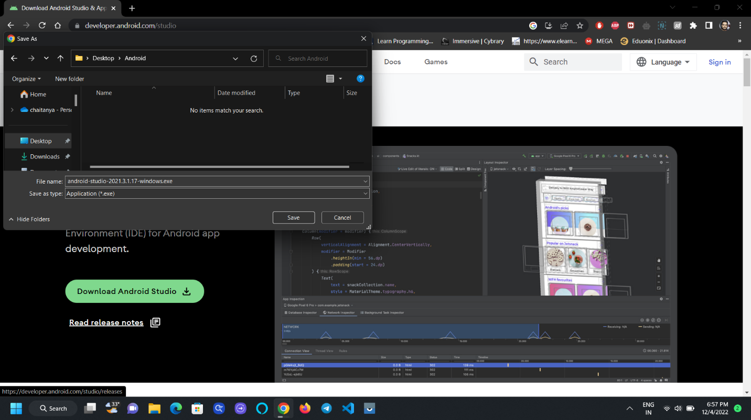

1. You can also check the downloaded file in the chrome browser by shortcut “Ctrl+J”.

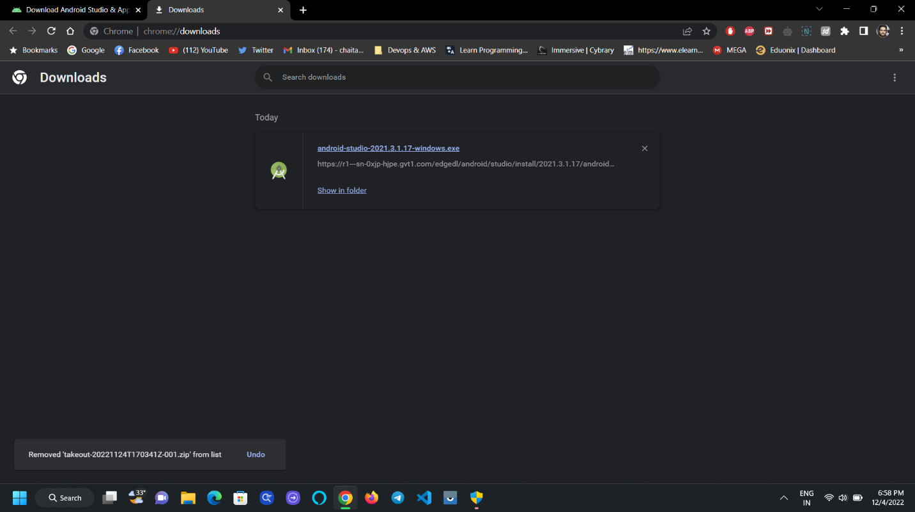

1. Click on the .exe file so that a pop will appear saying that it was loading.

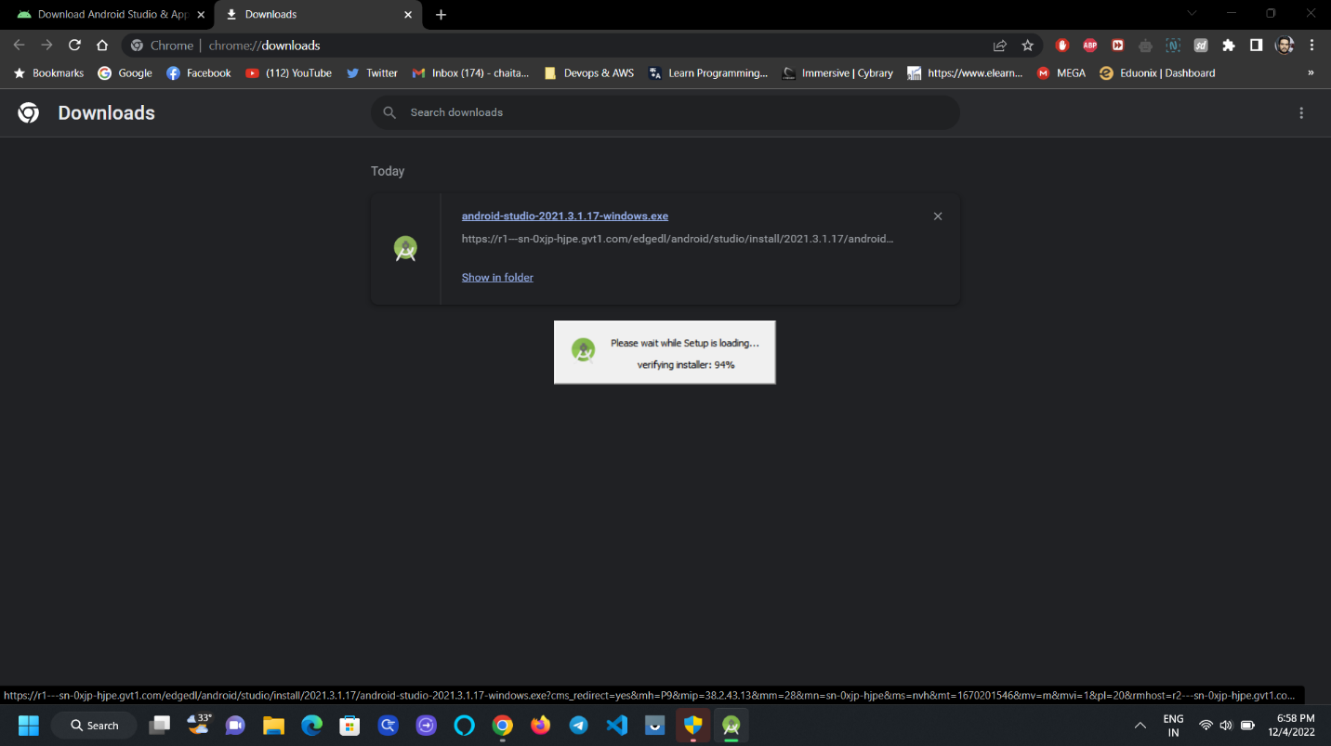

1. After 100% another popup will appear “Android Studio Setup” and click on next.

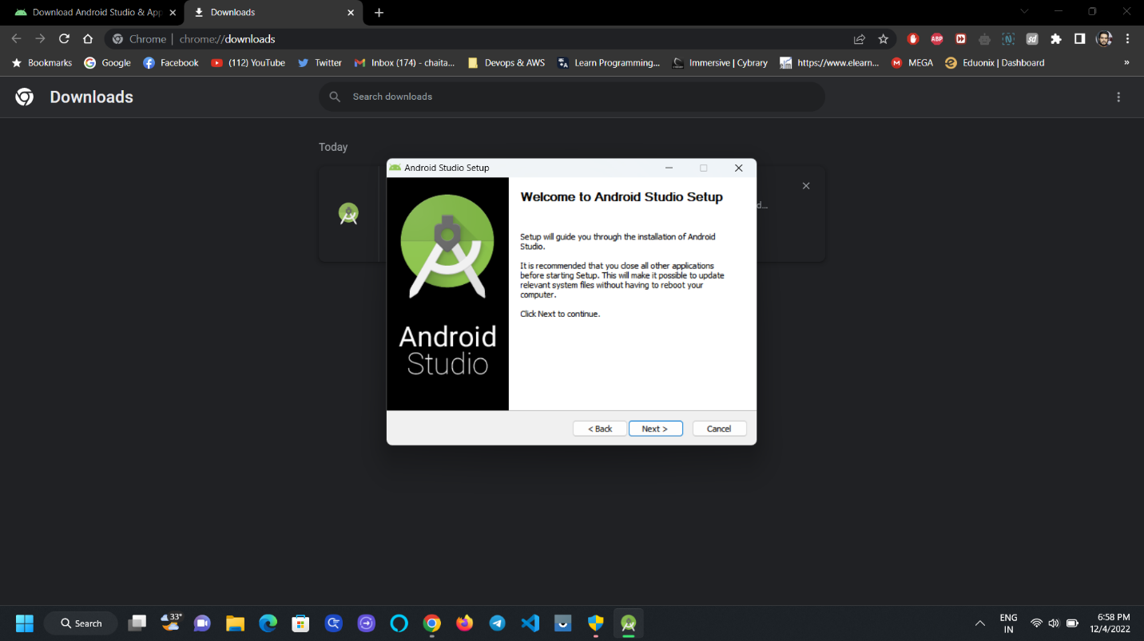

1. Click on Next, Next and then Install as shown in the below pictures.

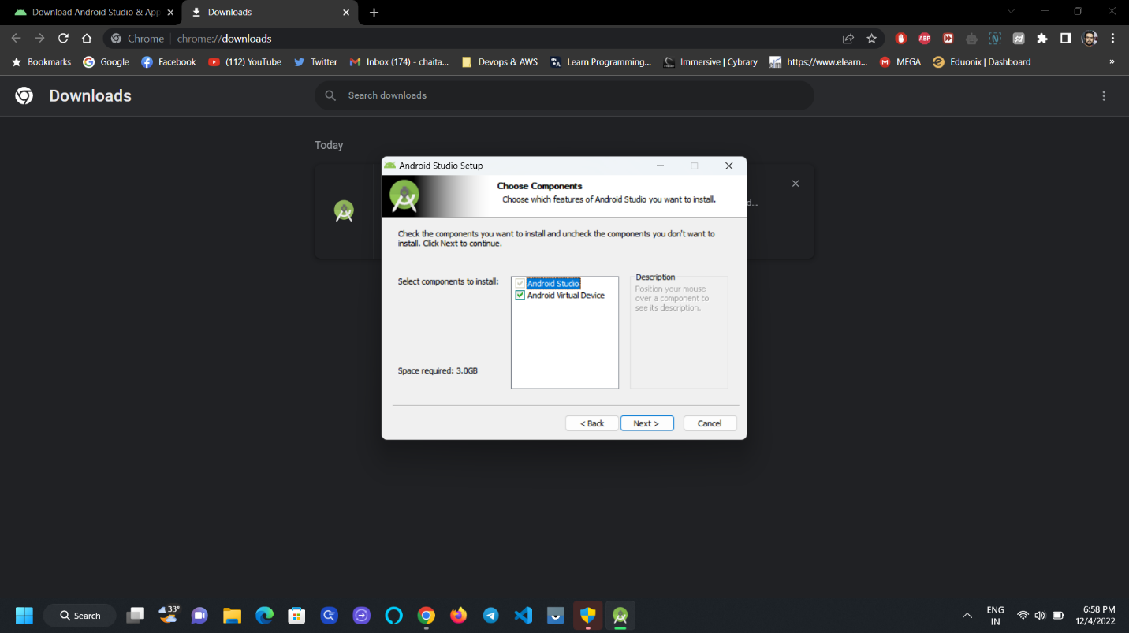

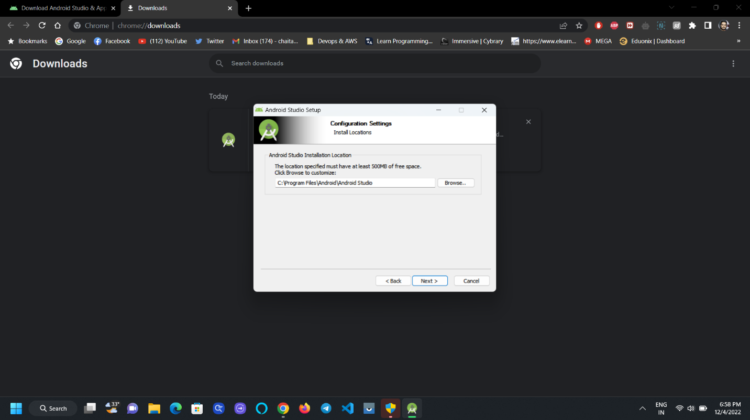

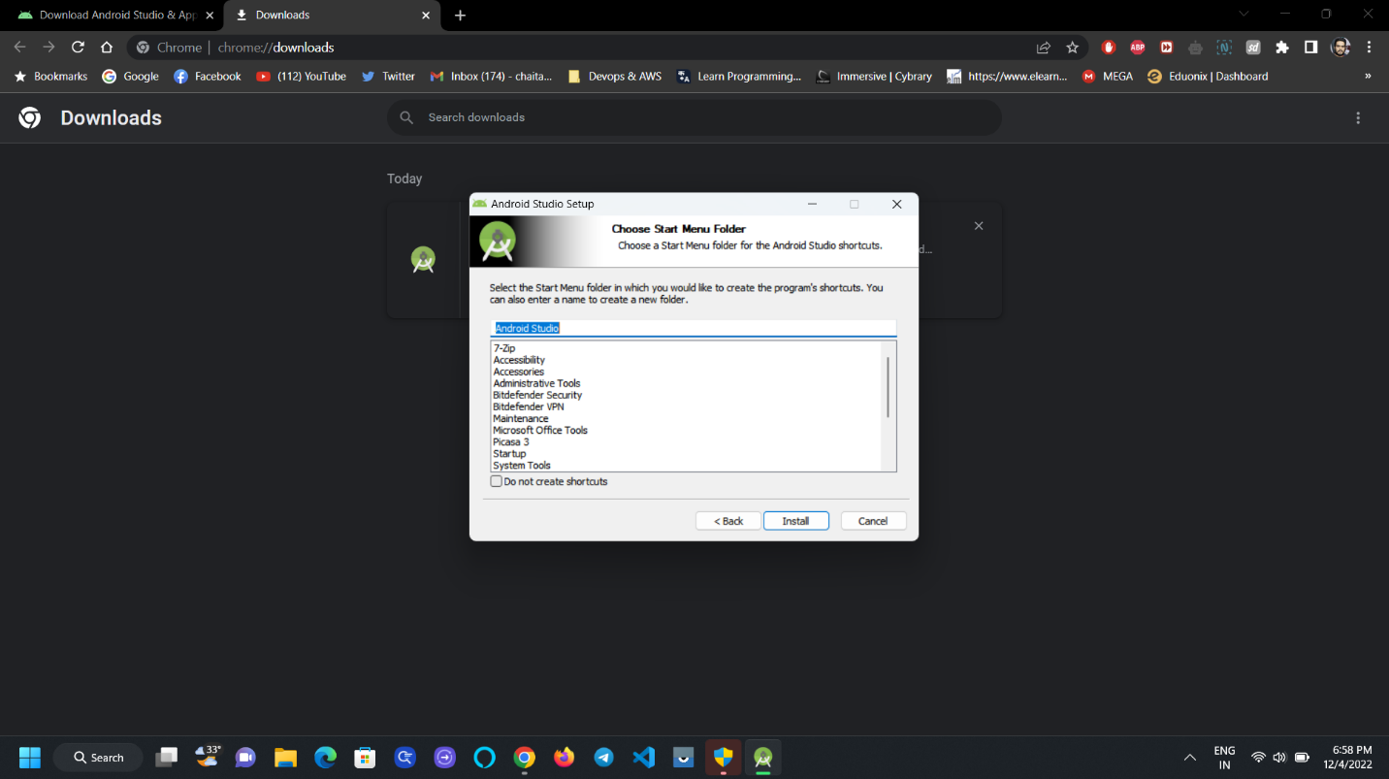

1. After finishing 100% Click on Next.

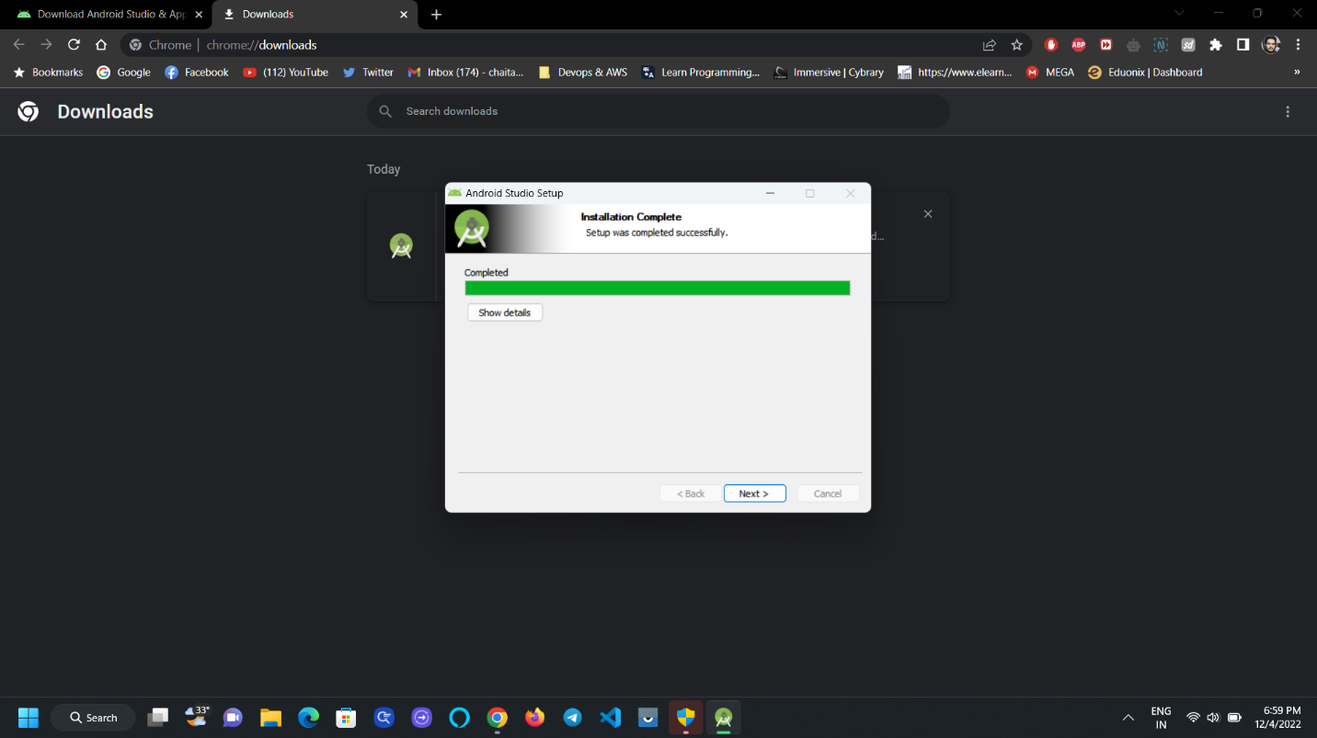

1. Check the check box and click finish.

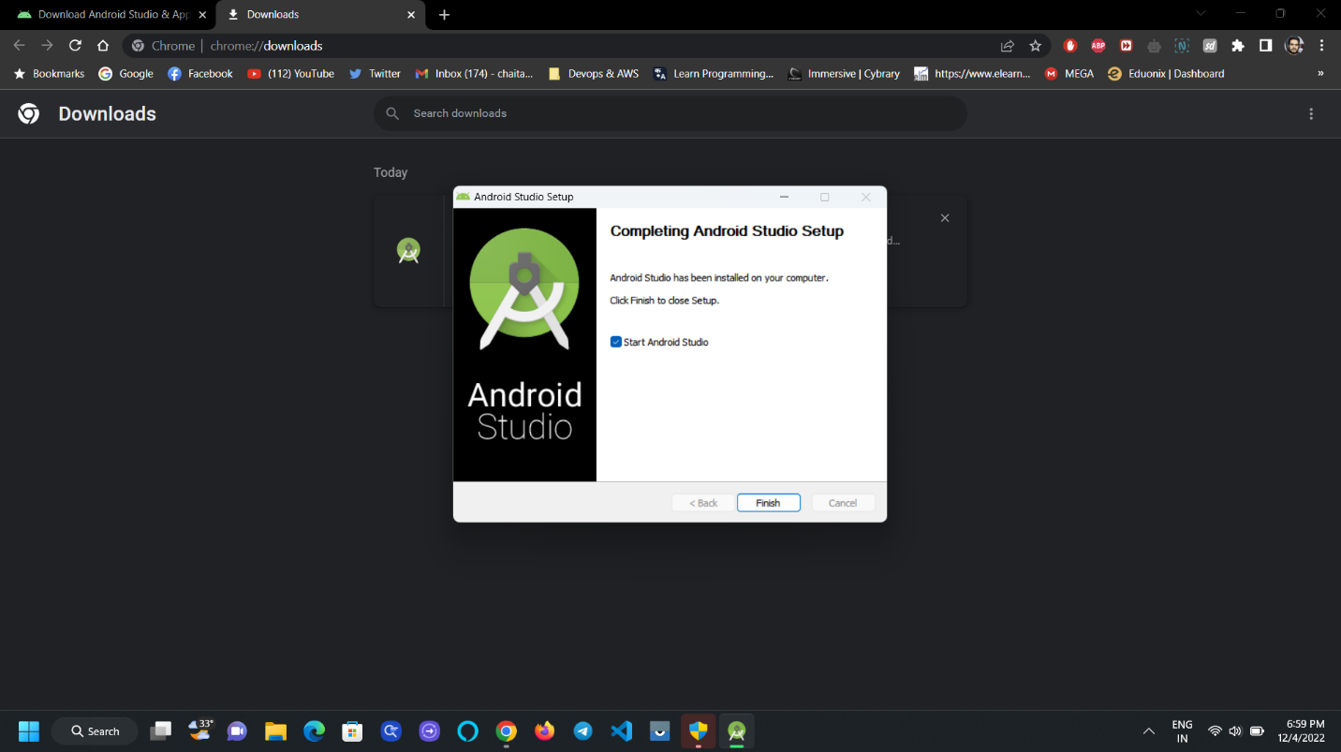

1. After clicking on finish a popup will appear and it will ask you to import the Settings, if you are first time user check the Don’t import Radio button and click Ok.

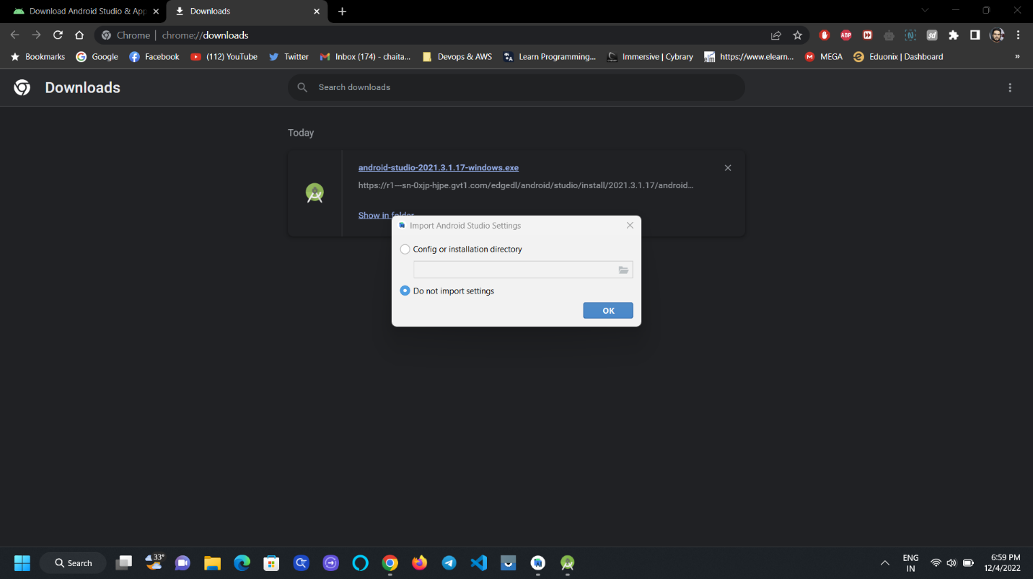

1. Android Studio will start loading, there are different versions of android studio, but when we are doing our project, we have used latest version that is “Dolphin version”

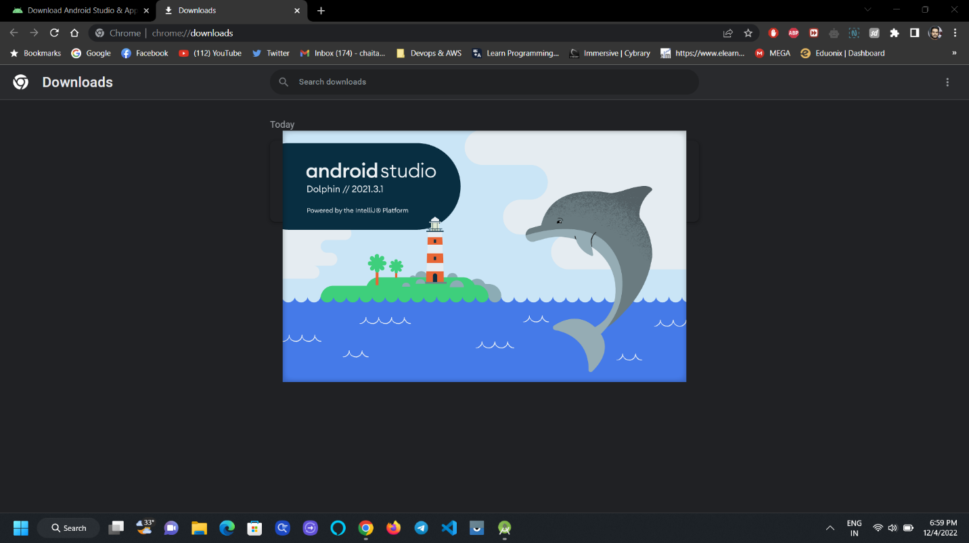

1. A welcome page will appear and it will ask for suggestions like Help improve android studio click on “Don’t send” and click on Next, Next.

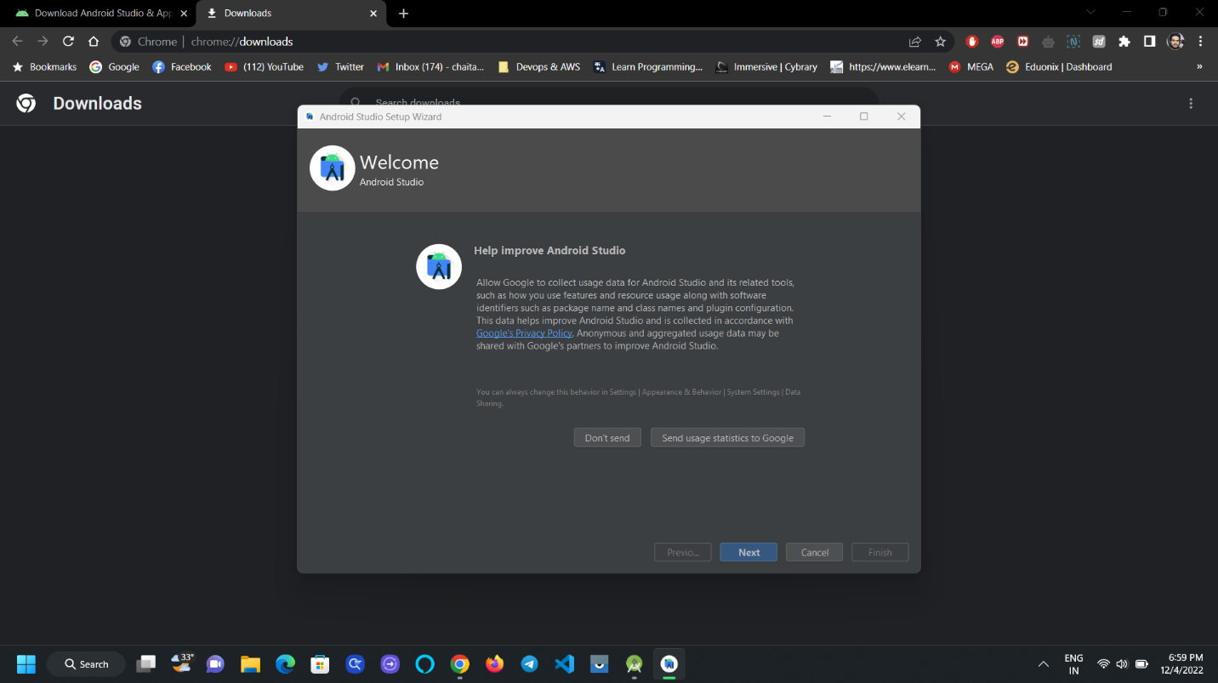

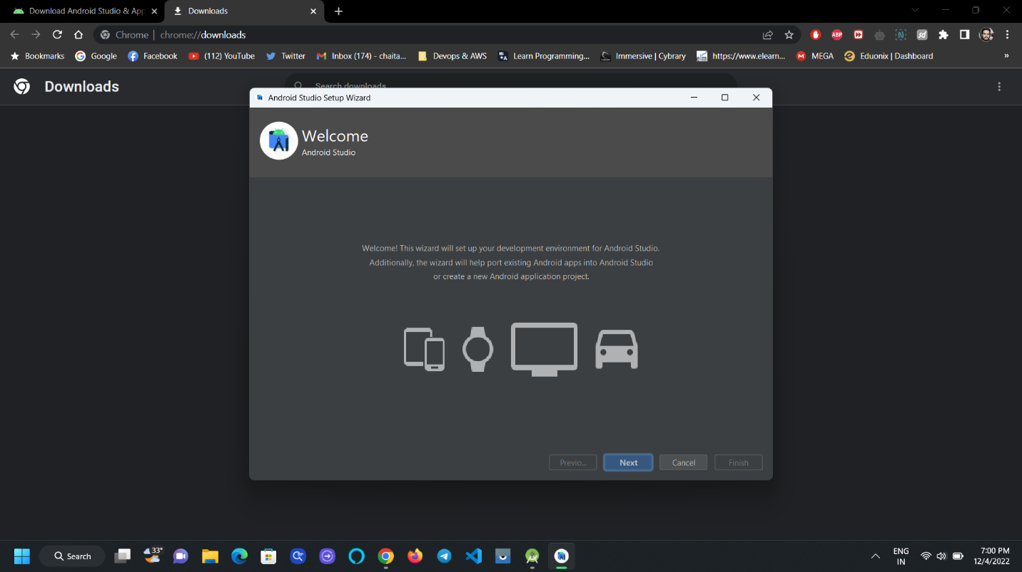

1. Choose Installation Type as Standard and click on Next.

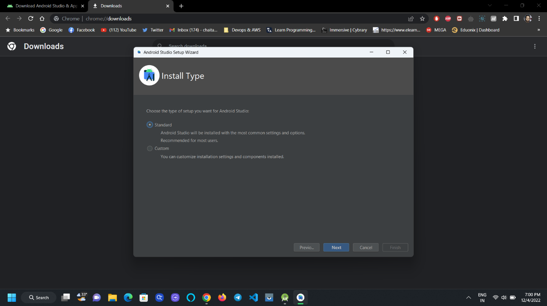

1. Select System UI Theme as you like.

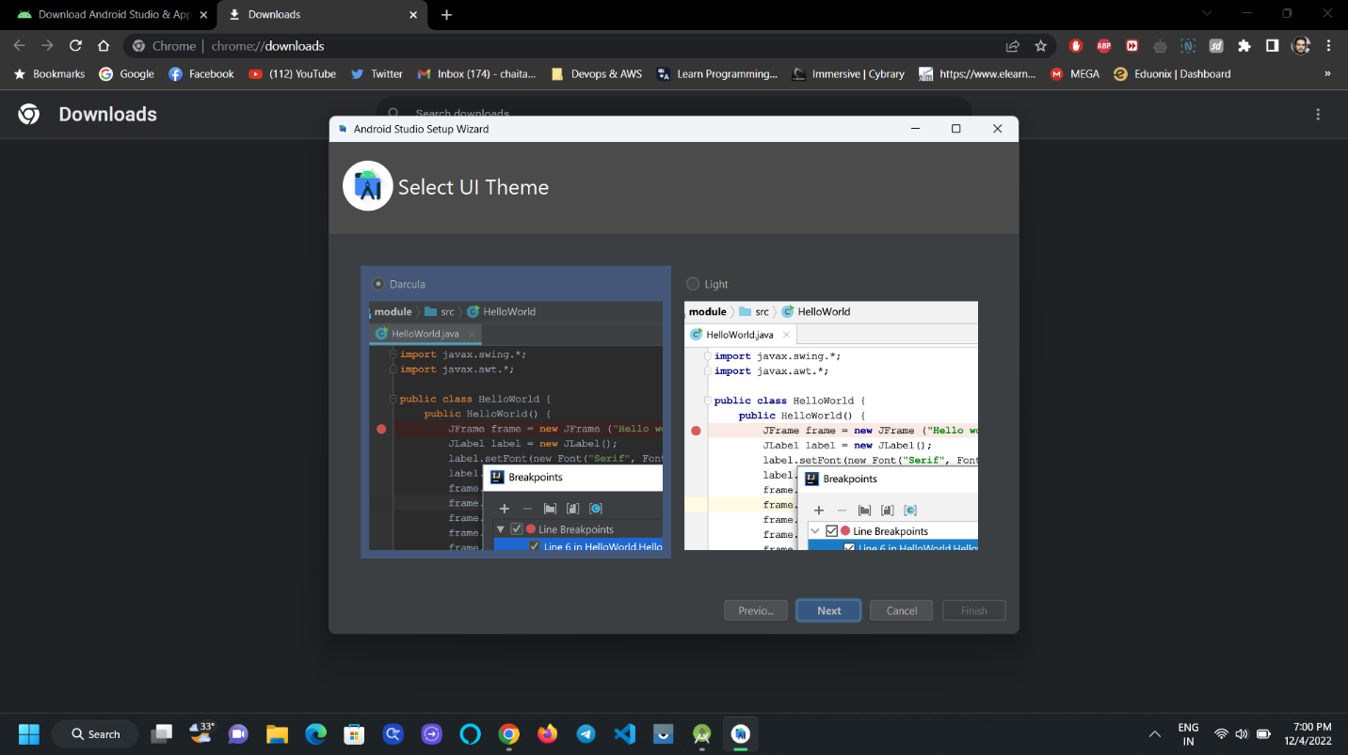

1. In the verify settings window you can observe many dependencies, libraries and some other supported software’s and click on Next.

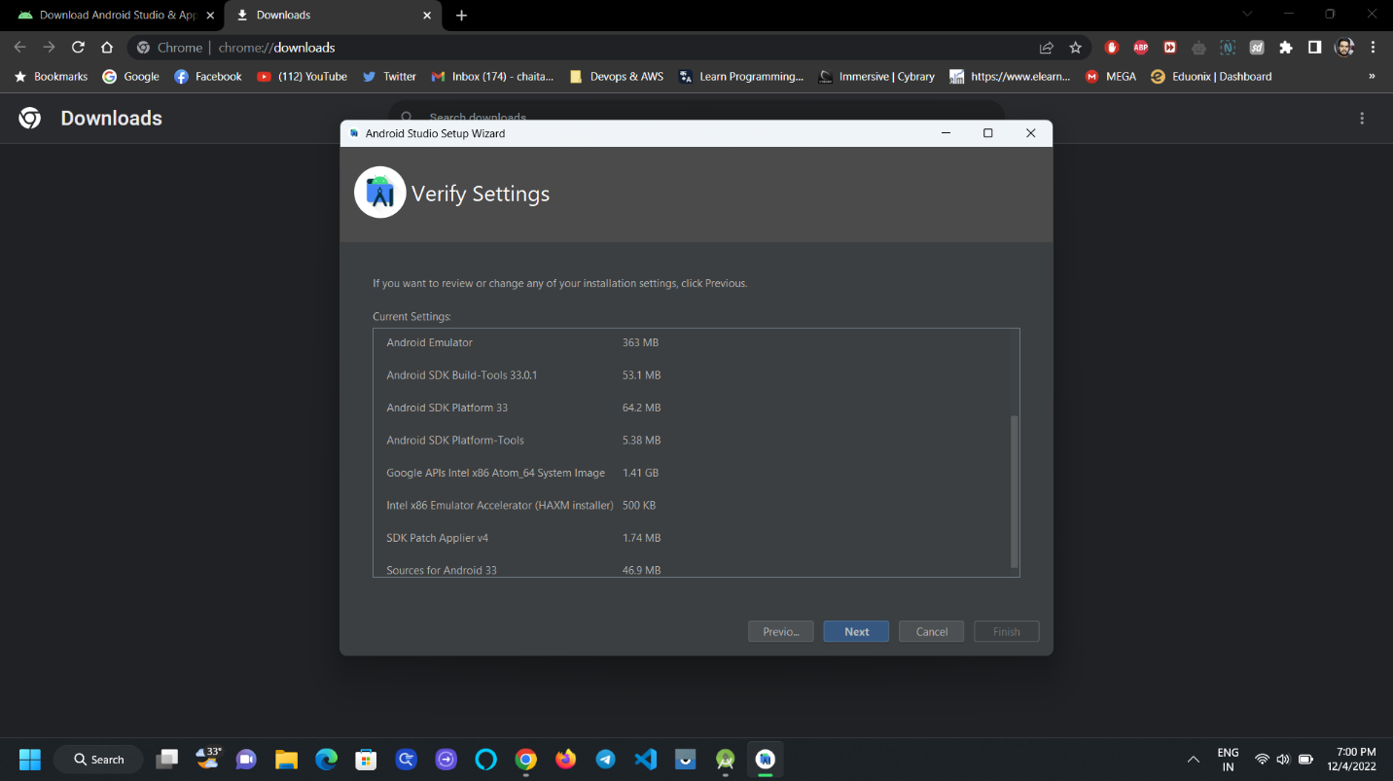

1. In the license agreement scroll down to accept the both the agreement and click on finish.

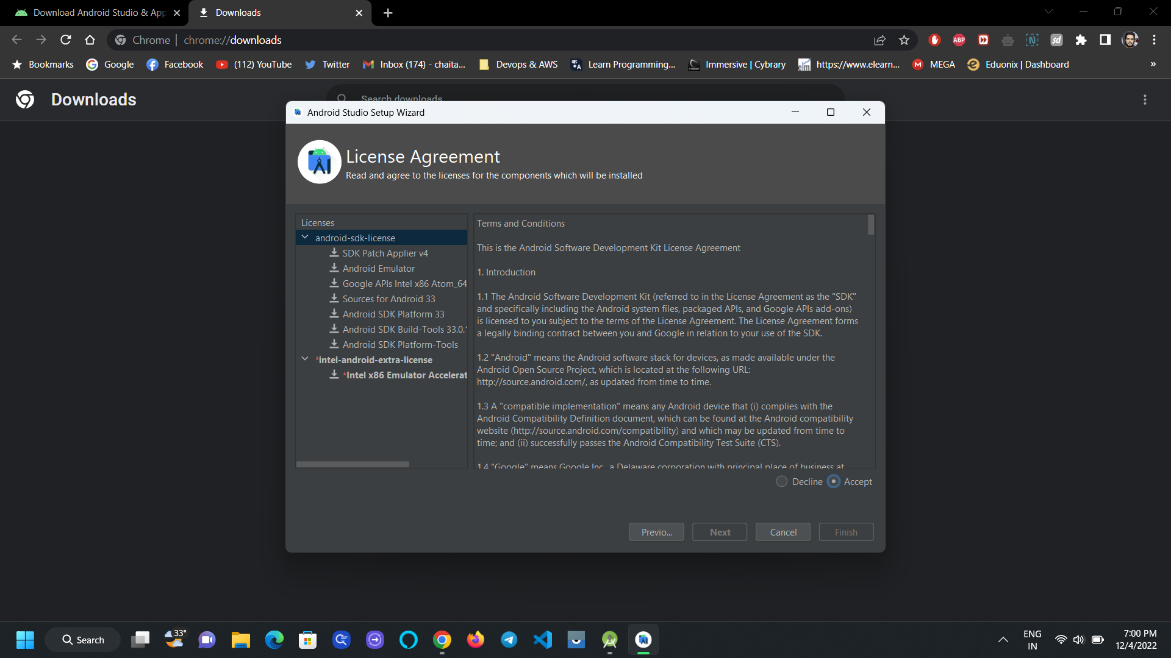

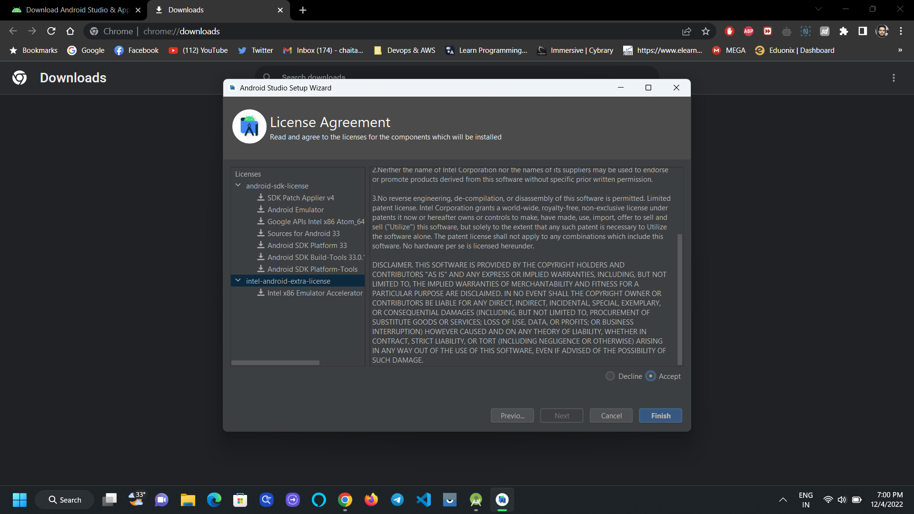

1. It will download some of the components for the studio and it will take some time.

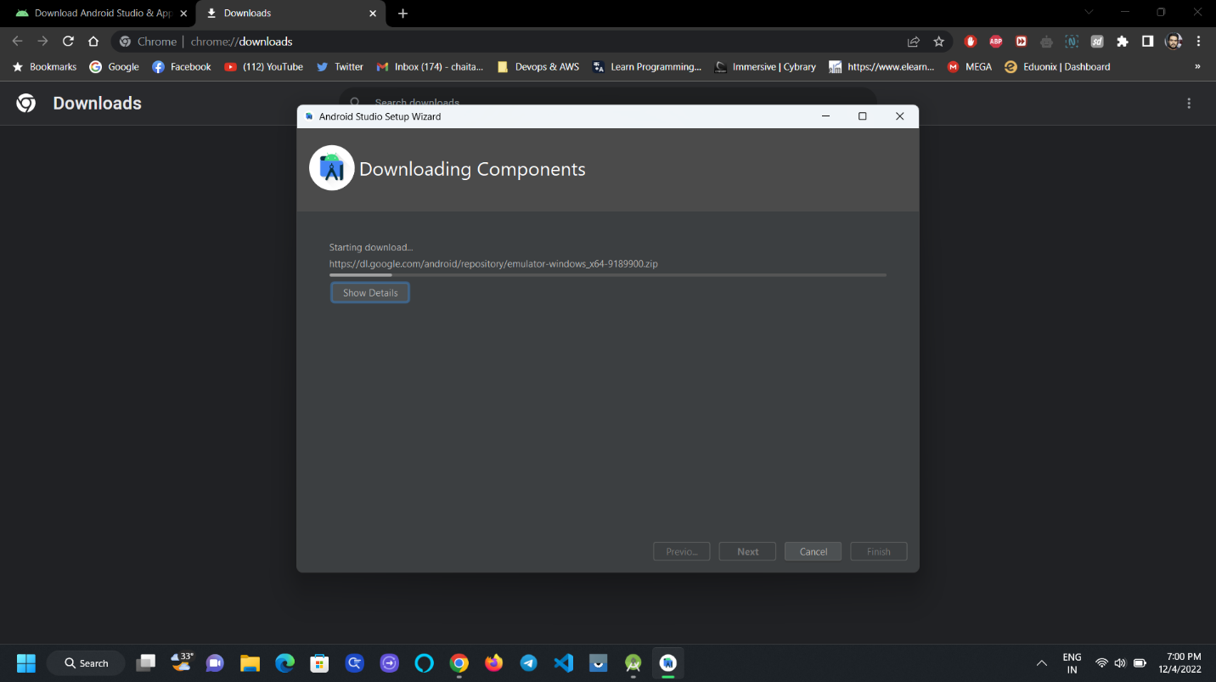

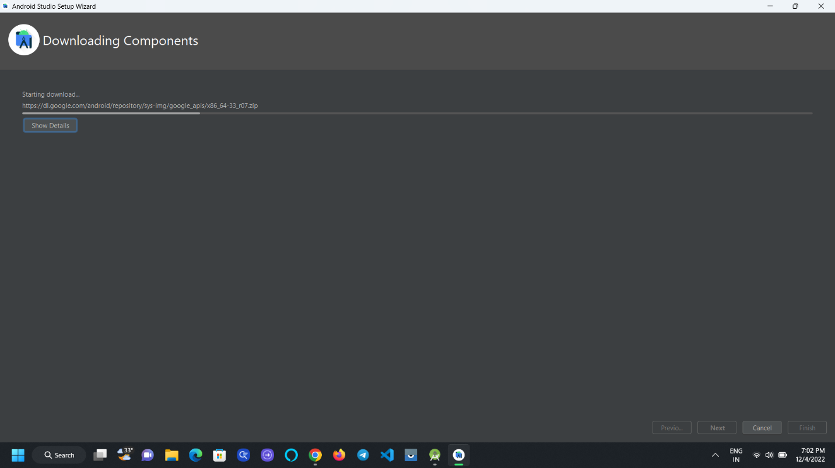

1. After downloading all the components click on finish.

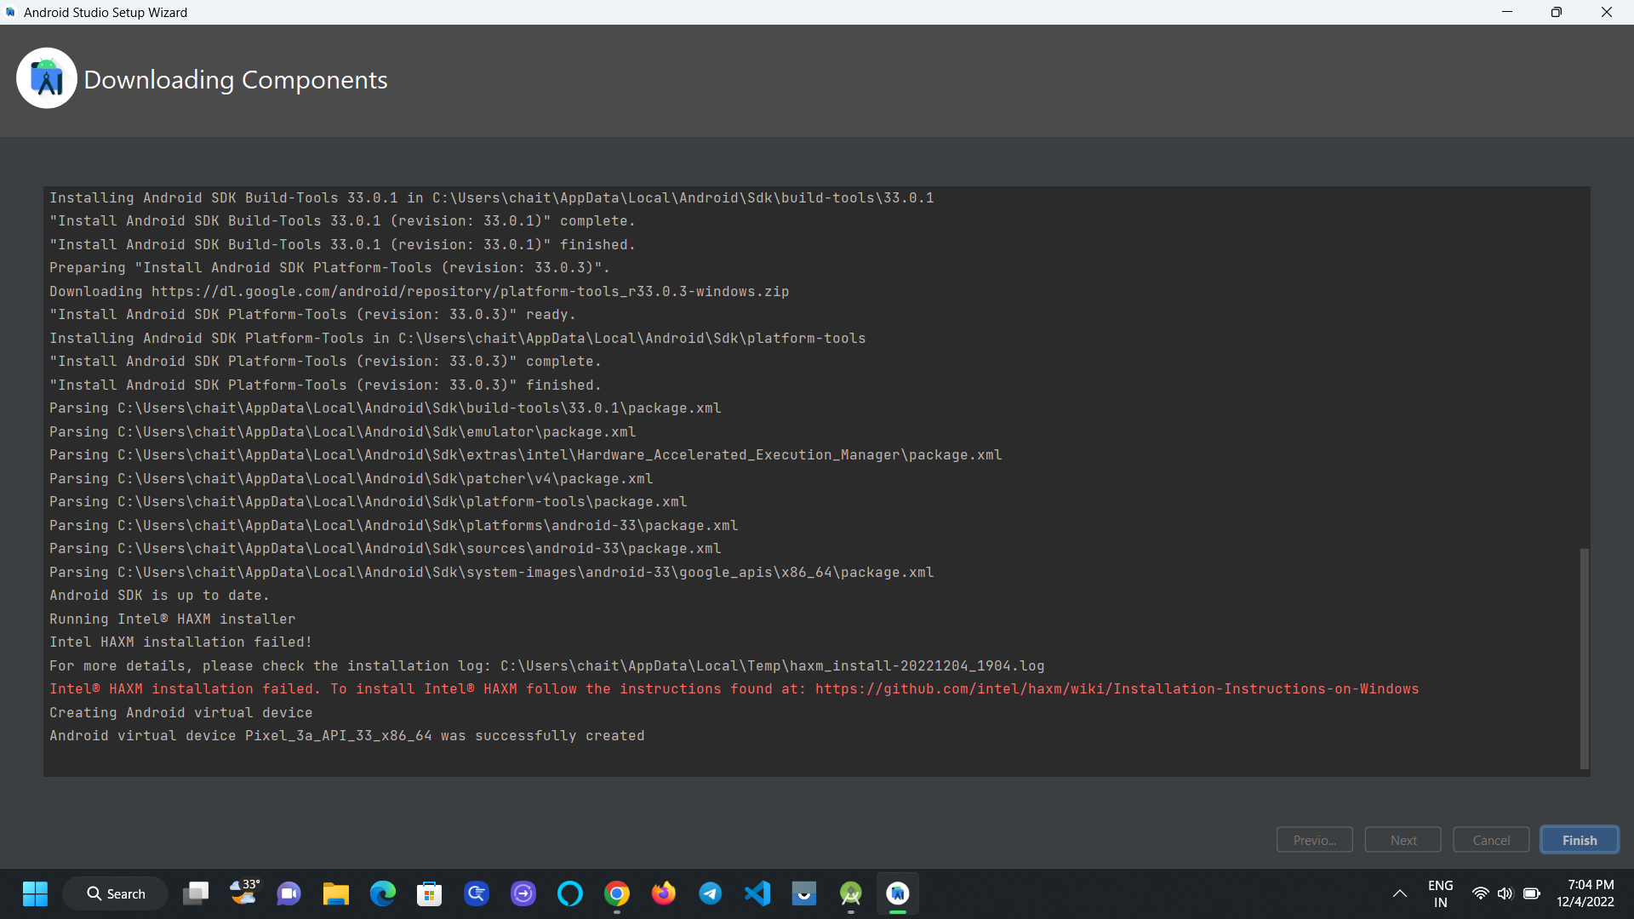

1. You can see the welcome page with some open other options like New Project, Open, from VCS.

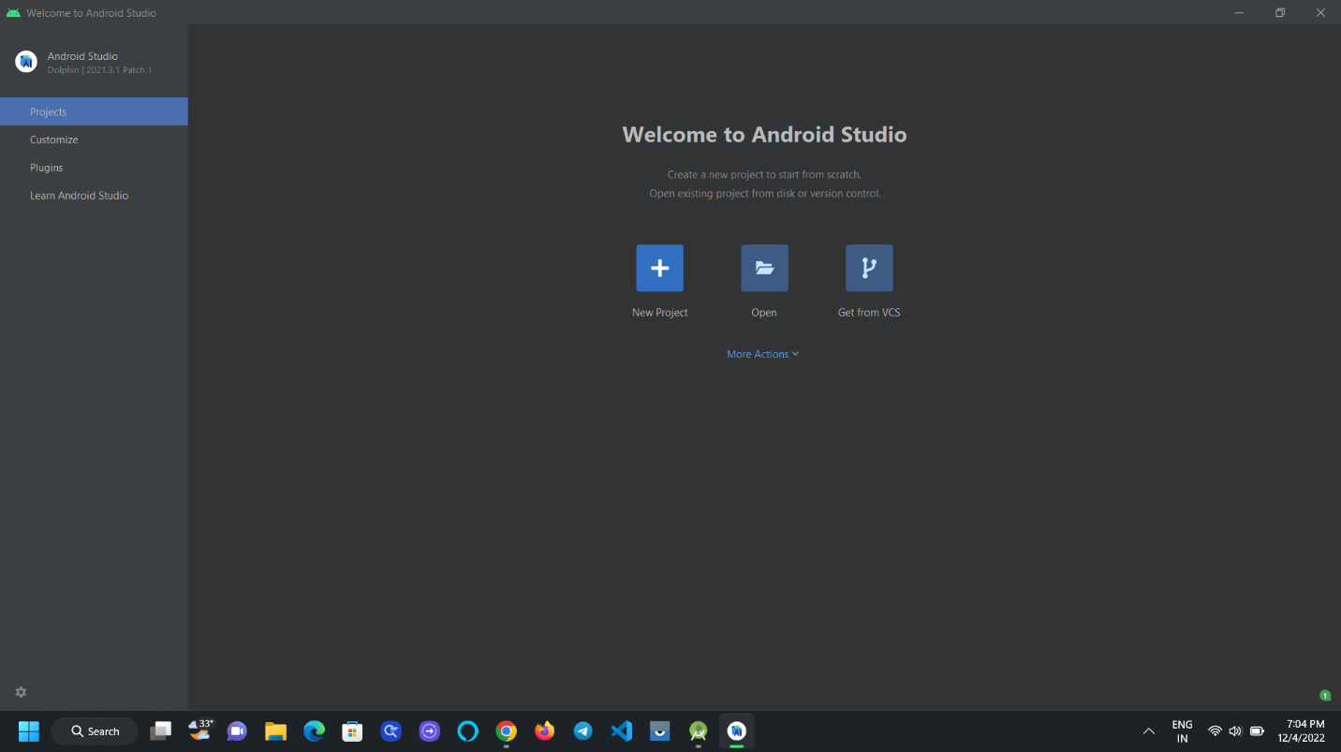

1. To open the project click on the GitHub link <https://github.com/EliteCrew11/Student-Attendance-Tracking-System> you can see the Remote repository window with repo name Student-Attendance-Tracking-System.

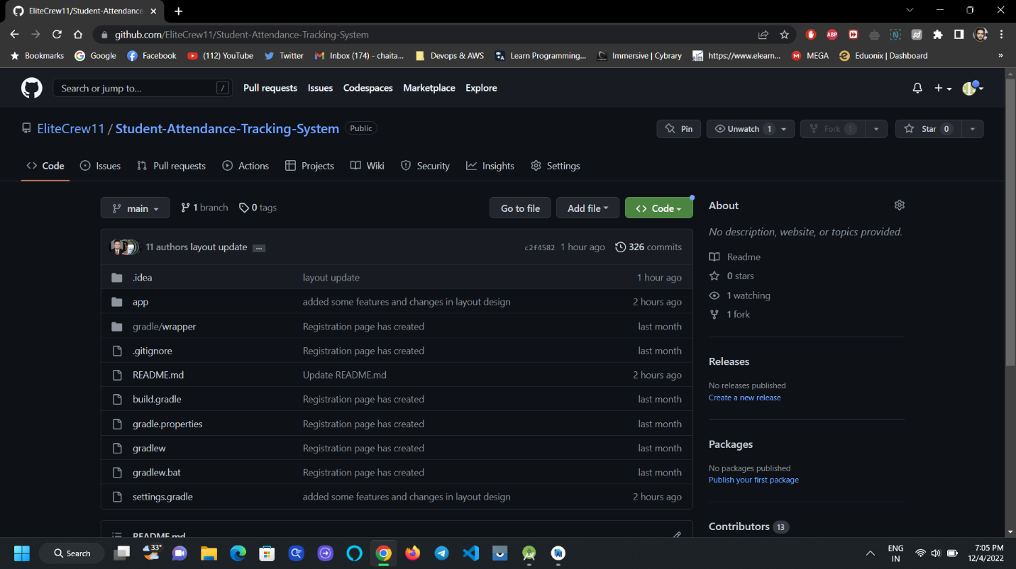

1. Click on the Green colored button named “Code” and click on the copy symbol beside the https link as shown in the picture.

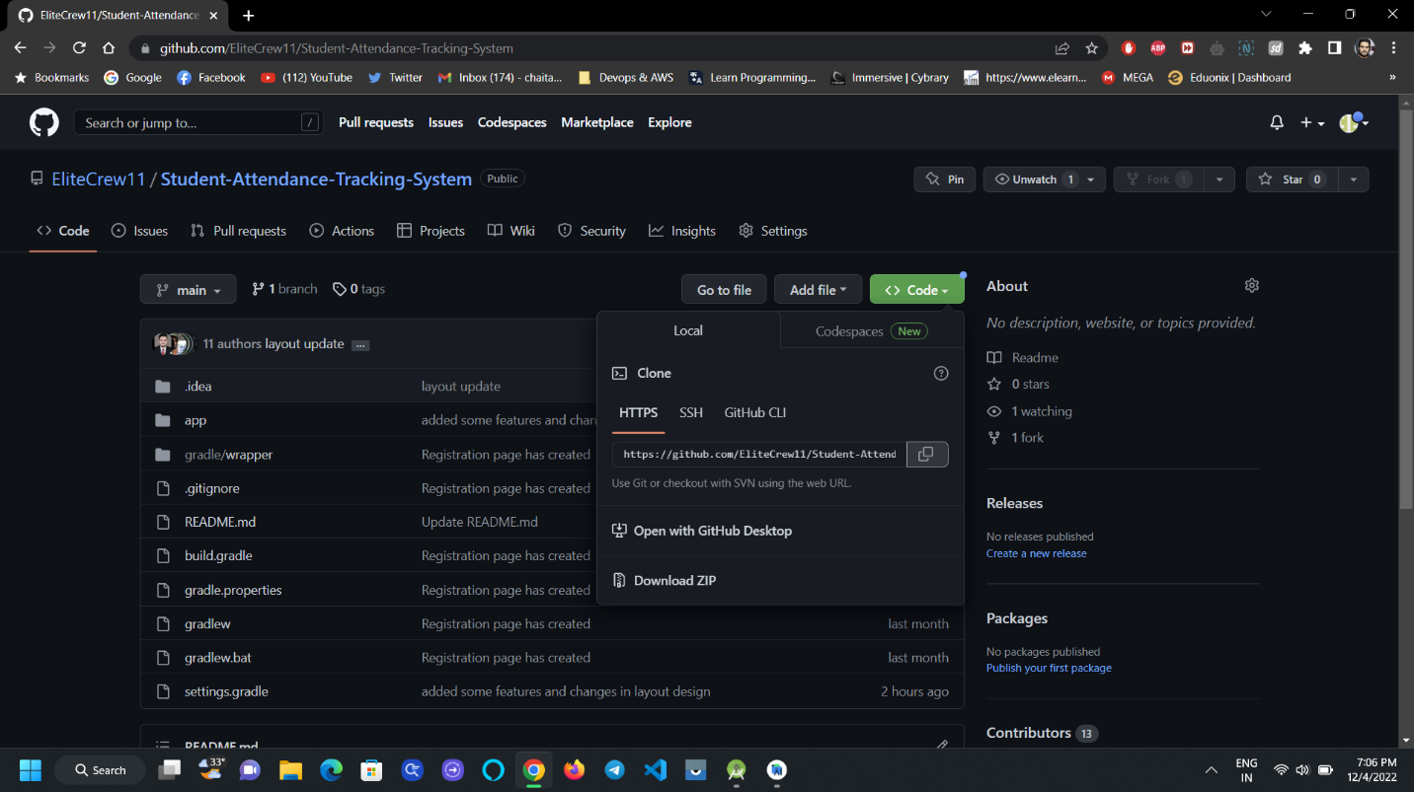

1. Now open the GitBash and set a path/directory where you want to clone the repository.

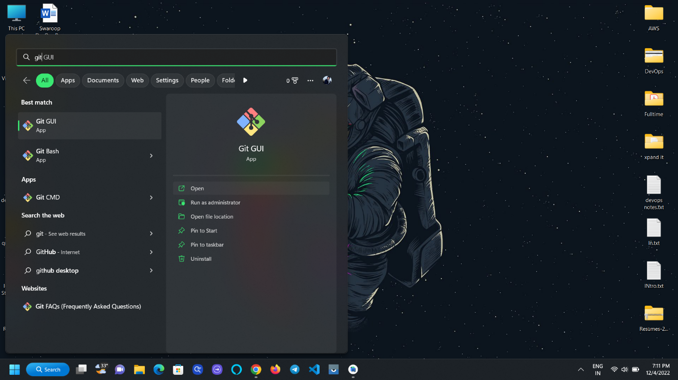

1. Set the desired path and Use the Command “git clone <https://github.com/EliteCrew11/Student-Attendance-Tracking-System.git>” to clone the repository into your local machine.

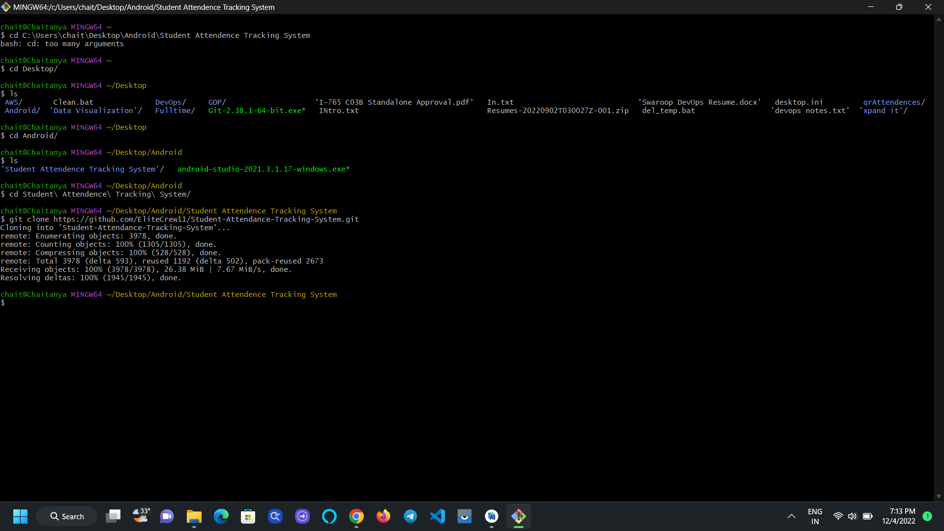

1. You can check the folder where you cloned the repository.

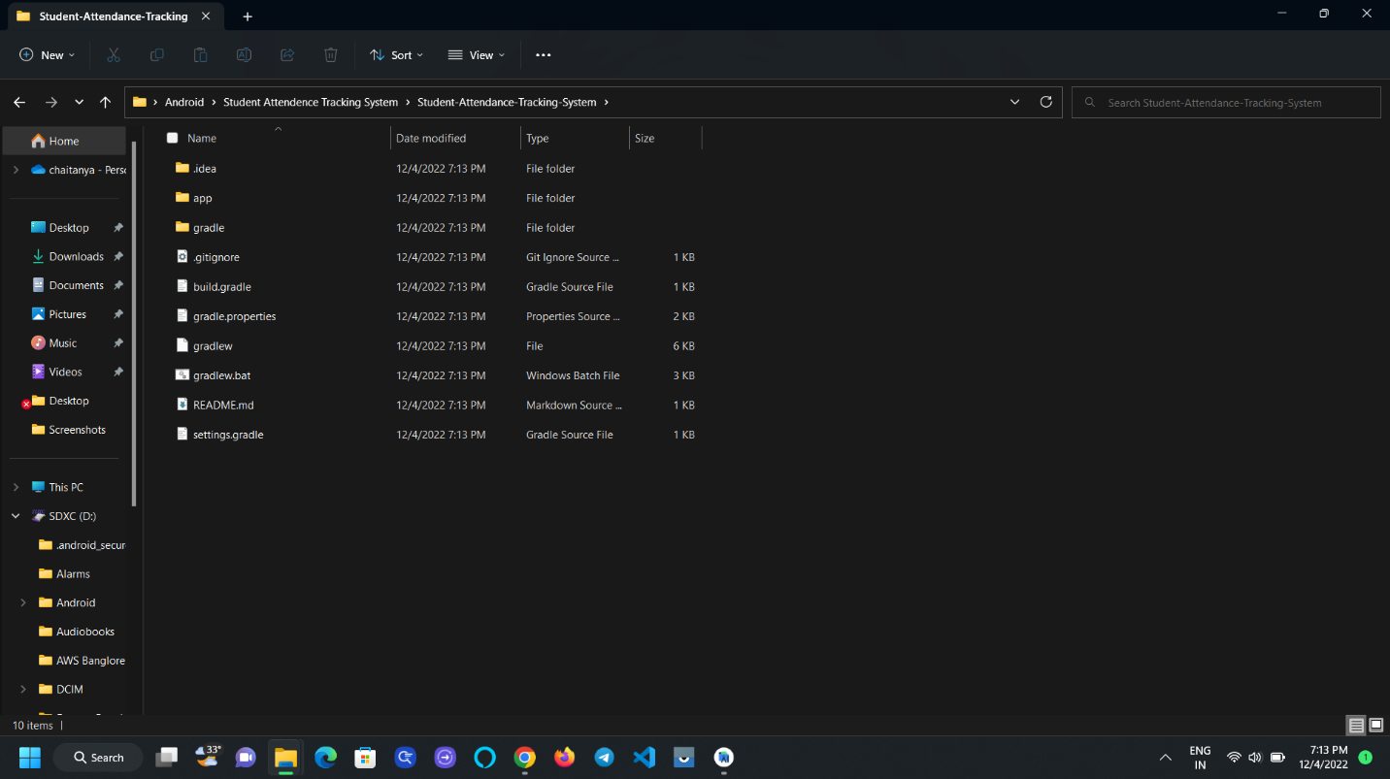

1. To open the project, open the “Android Studio” and click on the open and find the path where you cloned your repository in the local machine and click on the file where you see the file with android symbol as shown in the picture and click Ok.

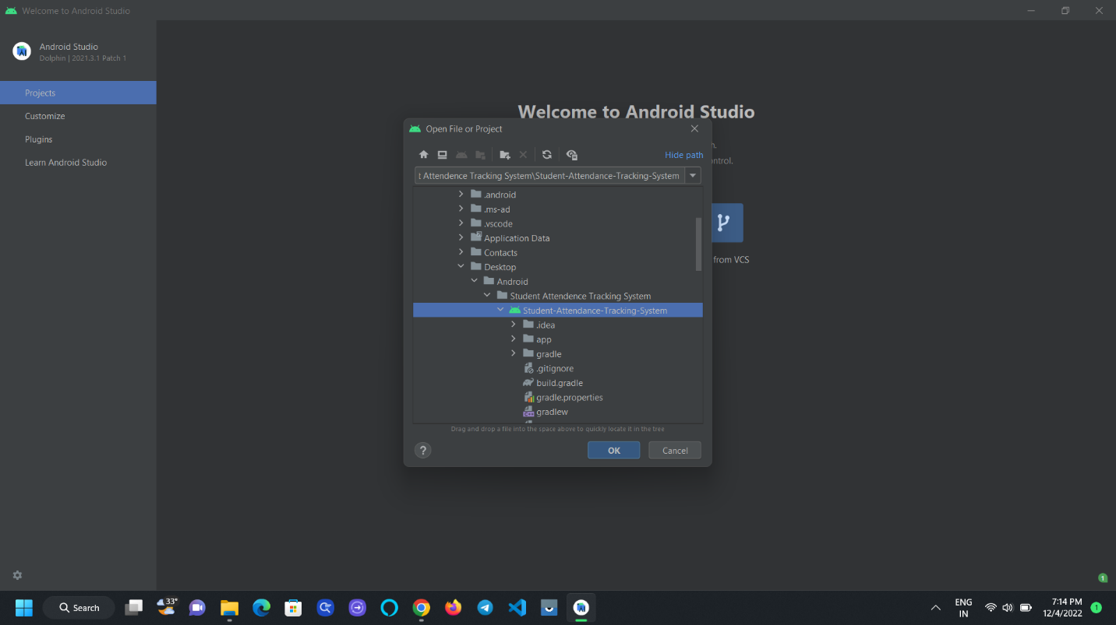

1. Another window appears states Trust and Open Project, check the check box and Click on the Trust Project Button.

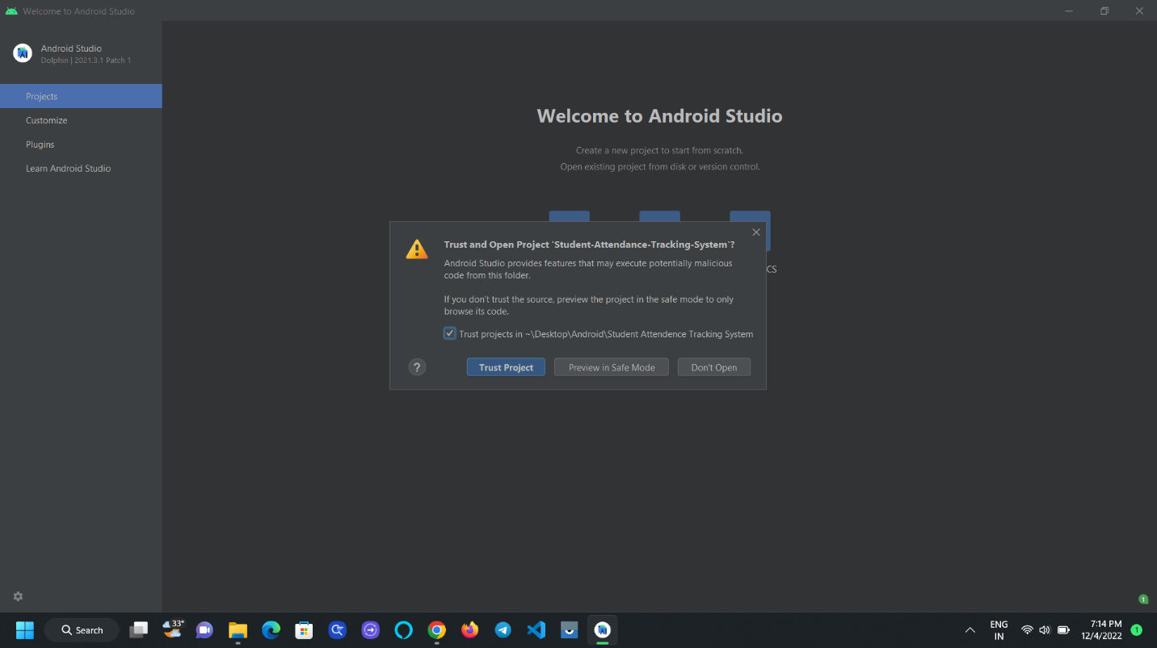

1. In the Bottom you can observe the loading symbol where some of the Gradle Properties and Dependencies are loading, wait for some time until they get loaded.

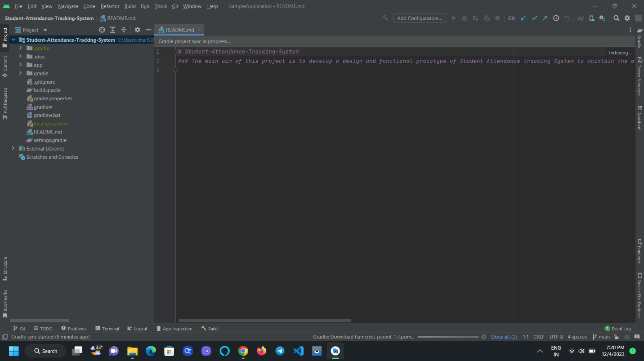

1. By clicking on the app folder we can see the sub folders like Manifest, Java, Res.

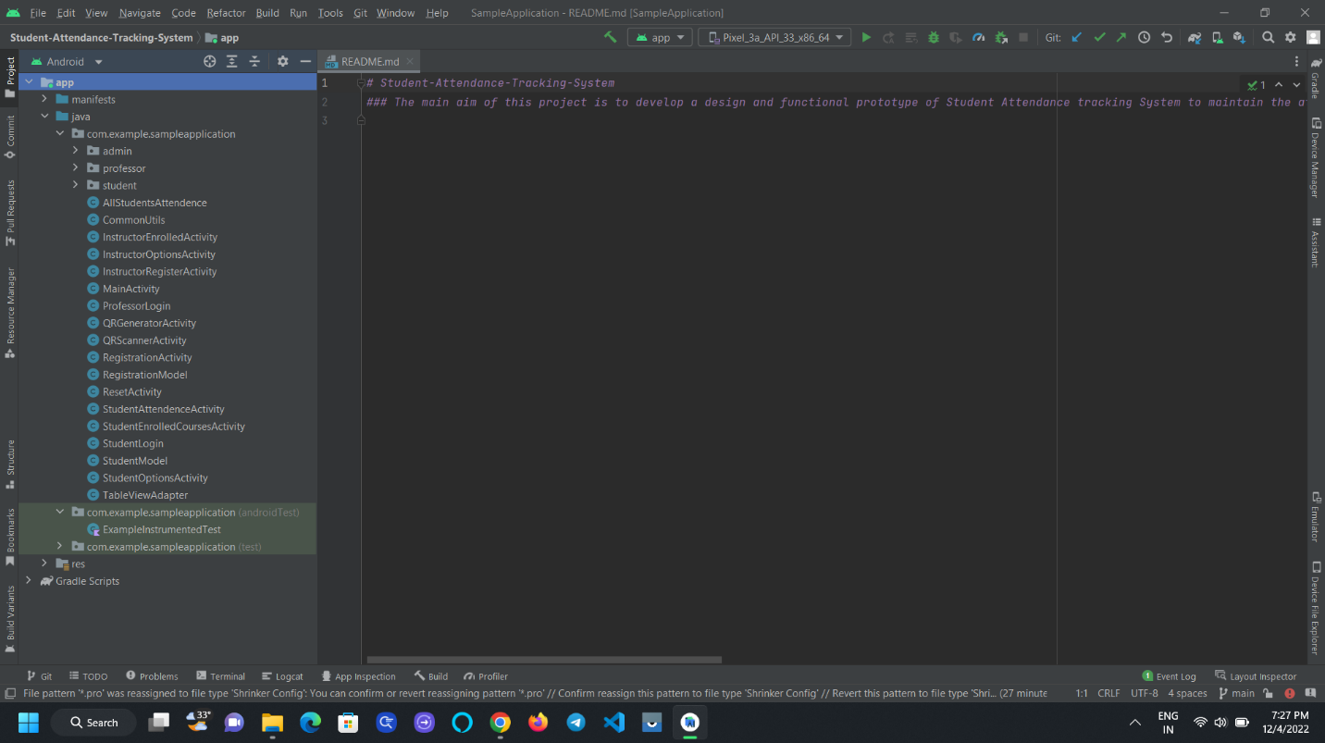

1. In the Manifest file contains the details of the project, In the java file where it contains the code and in the res folder contains the layouts.

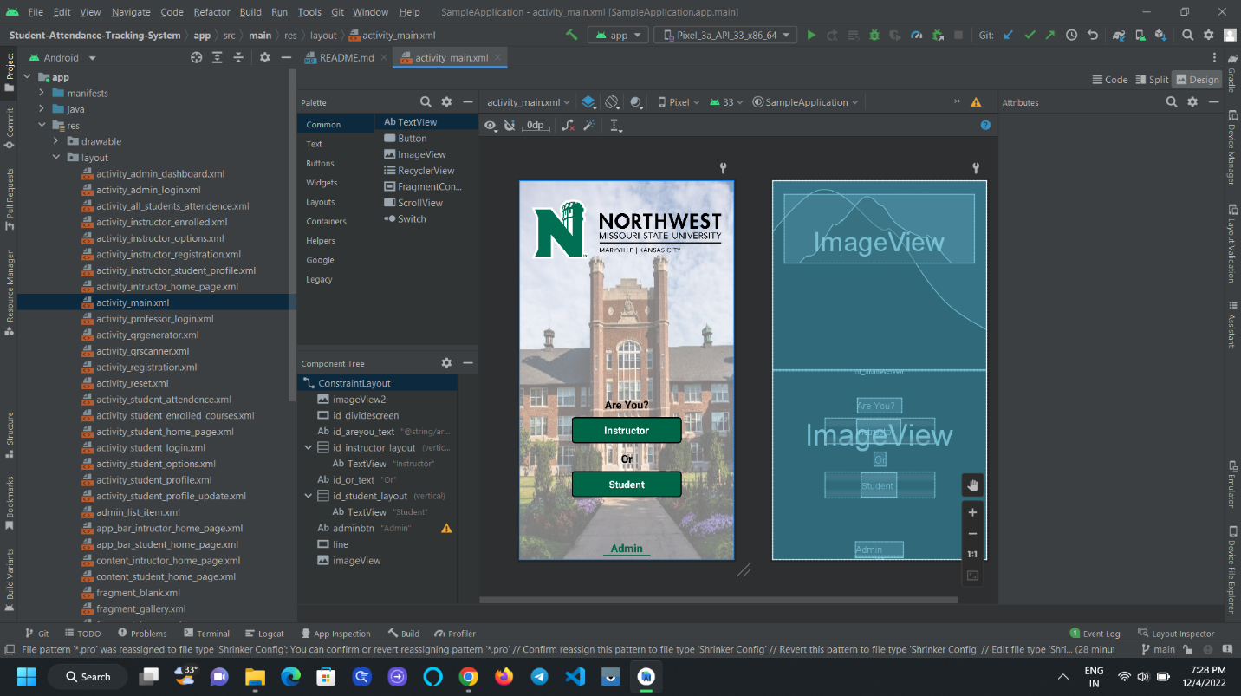

1. To build the apk click on the Build 🡪 Build Bundle 🡪 Build apk.

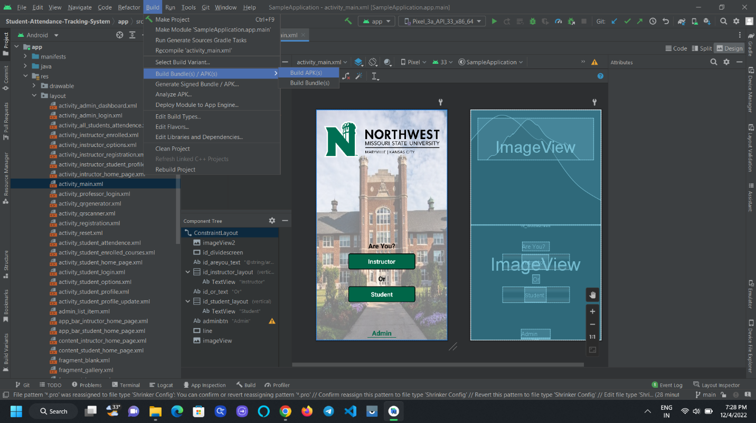

1. At the bottom you can see the Gradle build running and after that you can see a small popup at the bottom to locate the build apk.

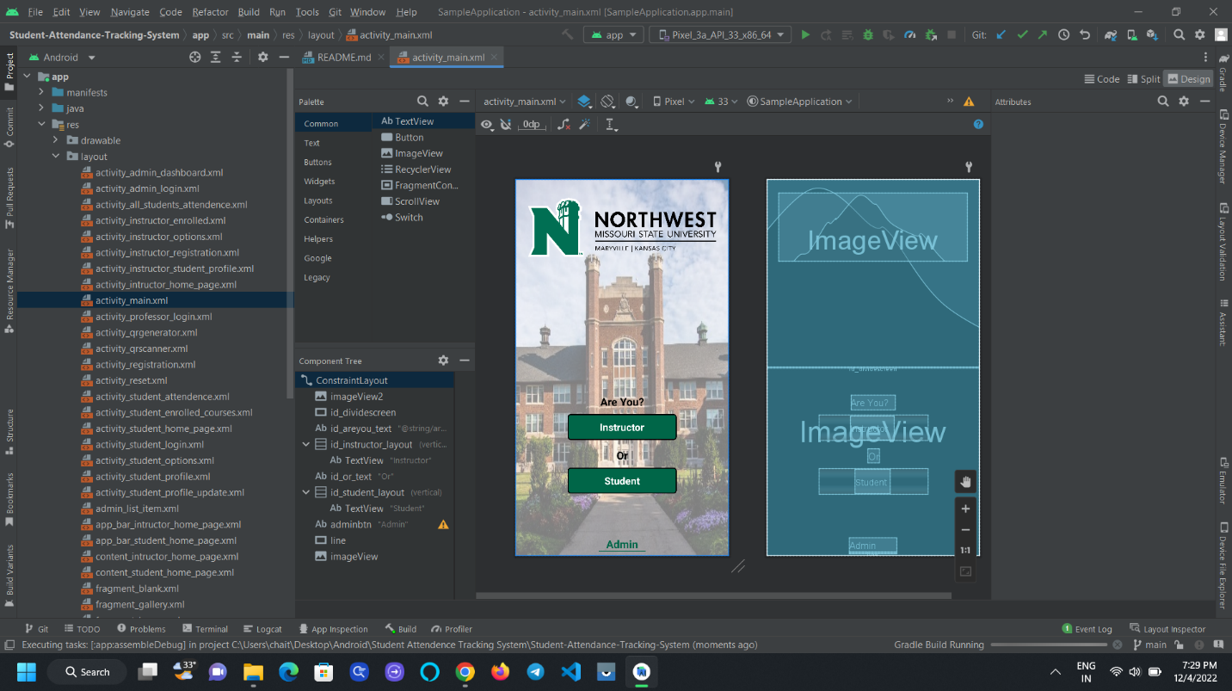

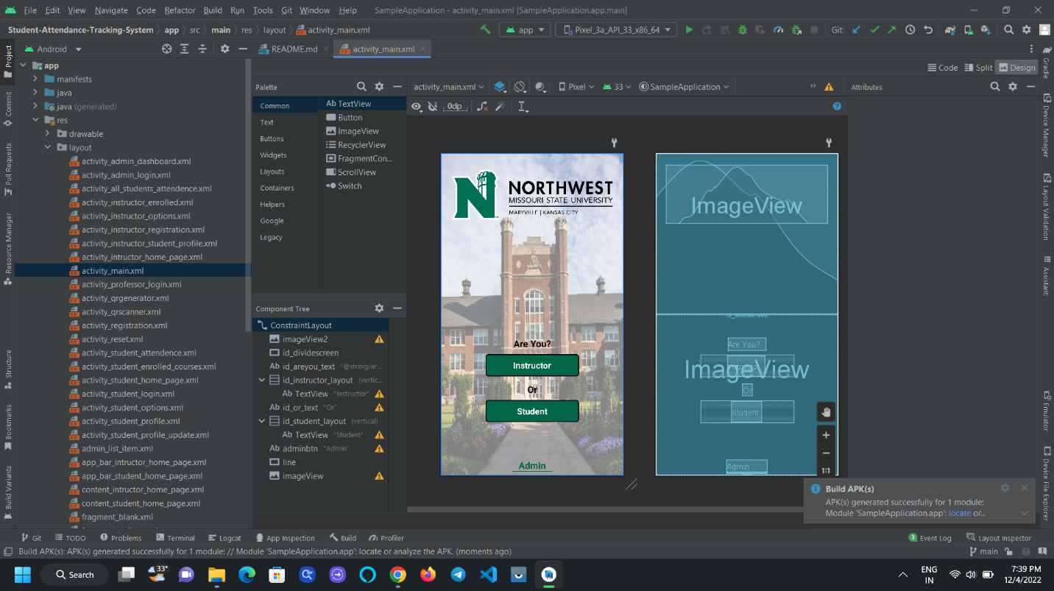

1. Clicking on the locate you will be redirected to the folder where the apk build.

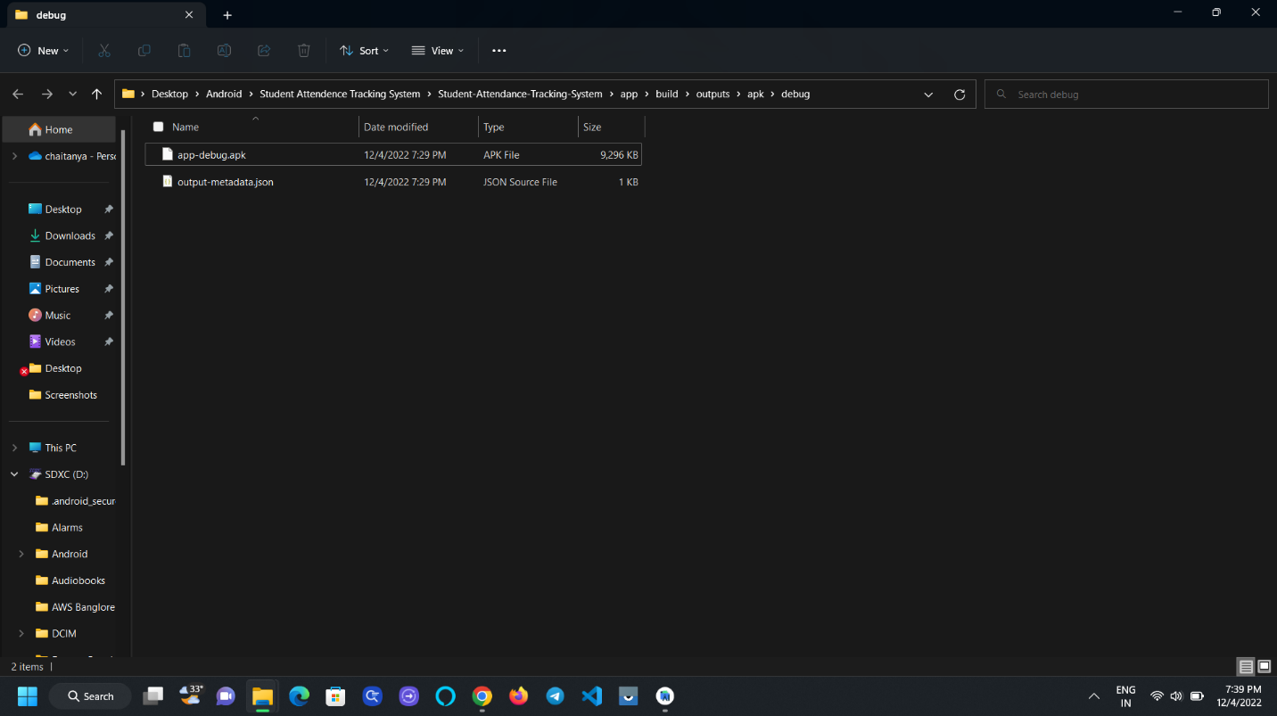

1. The app name by default is app-debug.apk it won’t allow you to install the apk as you need to change the name of the apk as you like and you’re ready to install.

